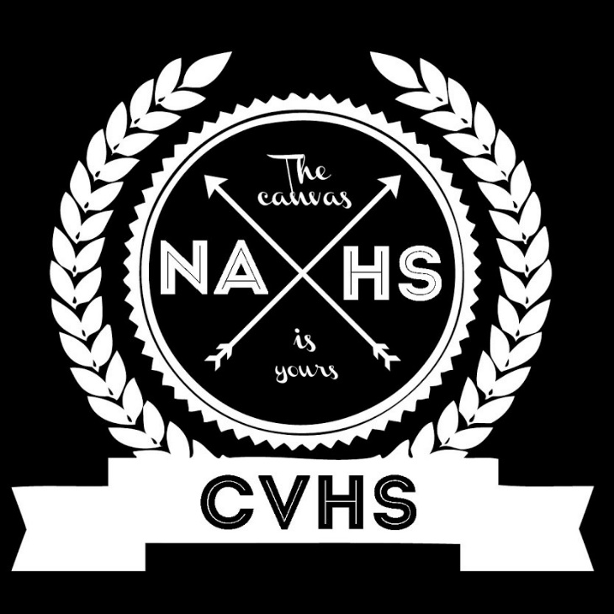
NAHS ORDER FORM FOR ART CLUB ATTIRE
TURN THIS FORM IN TO MS. WILSON WITH YOUR PAYMENT OF CASH OR CHECK- make check payable to CVS

NAME:_______NAHS SHIRT ORDER_______________DUE: _____

Short Sleeved T | $15 | Size  S M L XL 2 X
Long Sleeved T | $20 | S M L XL 2X

